**FYP Proposal**

**Smart Navigation Assistant Robot (SNAR)**

Submitted by:

**Saqib Ali**

**Reg. AUIC-21FL-BSSE-6290**

**Abu Hurrara Javed**

**Reg. AUIC-21SG-BSCS-5454**



Supervised by:

**Maam Ayesha Amjid**

Final Year Project proposal submitted to the Department of Computing, Abasyn University Islamabad Campus in partial fulfillment of the requirements for the degree of Bachelor of Science in Computer Science (BSCS) or Bachelor of Science in Software Engineering (BSSE).

**Department of Computing**

**Abasyn University Islamabad Campus**

**Fall 2021**

|  |  |  |  |  |  |  |  |  |
| --- | --- | --- | --- | --- | --- | --- | --- | --- |
| Project Title: | | | **Smart Navigation Assistant Robot (SNAR)** | | | | | |
| Date of Submission | | | **23-09-2024** | | | | | |
| Project Status  (Tick any one) | | | 🗆 New Proposal | 🗆 Modification | | | | 🗆 Re-Submission |
| **Students’ Information** | | | | | | | | |
|  | | **Student-1** | | | | **Student-2** | | |
| Reg. No. | | **6290** | | | | **5454** | | |
| Name | | Saqib Ali | | | | Abu Hurrara Javed | | |
| Contact No. | | 03340584927 | | | | 03135423160 | | |
| email | | 03340584927wer@gmail.com | | | | hurrarach@gmail.com | | |
| Signatures | | **Saqib Ali** | | | | **Abu Hurrara Javed** | | |
| **To be filled by the supervisor** | | | | | | | **Specify the tools used** | |
| 1. | Which method(s)/algorithm is used for project development? | | | | | | Libraries such as Google's Speech Recognition API,CMU Sphinx can be used to recognize and process voice-commands,image processing algorithms,Text-to-Speech (TTS). | |
| 2. | Which tool(s) used for method/ algorithm development? | | | | | | Visual-Studio,Arduino IDE,Raspberrypi. | |
| 3. | Which development model to be followed? ( Annex-I, Sec-1) | | | | | | Agile Process Model | |
| 4. | Which tool(s) will be used for system design? ( Annex-I, Sec-2) | | | | | | UML-Diagrams,Flow charts,Er Diagrams,System Architecture tools. | |
| 5. | Which technologies will be used for the system development? ( Annex-I, Sec-3) | | | | | | Arduino,Raspberrypi,Sensors | |
| 6. | Which tool(s) is used for Work Breakdown Structure (WBS)? ( Annex-I, Sec-4) | | | | | | Microsoft Project | |
| 7. | What is each student’s contribution in terms of man month as mentioned in  **Work Breakdown Structure (**WBS)? ( Annex-I, Sec-5) | | | | | | St1.Development and Testing  St2.System Design and Documentation | |
| Name of Supervisor | | **Maam Ayesha Amjid** | | | Supervisor Signature | | **Ayesha Amjid** | |

**Department of Computing**

**Project Proposal Submission Form**

|  |
| --- |
| **Project Type:** (tick appropriate type)   * Research Work * Development * Research and Development * Desktop Based Application * Web Based * Mobile Application |

# Introduction

Finding rooms, shops, or specific locations like ICU wards within large buildings such as universities, malls, and hospitals can be a frustrating experience for many individuals. The complexity of navigating these spaces often leads to confusion, particularly in settings where time is crucial, such as hospitals or universities. Whether it's a student looking for a particular lecture hall or a visitor trying to locate a shop or ward, the need for an intelligent system that simplifies this process is evident.

The project "Robo: LocoBot" is aimed at addressing this problem by developing a smart AI-powered robot that assists users in finding rooms, shops, wards, or ICU locations within large public buildings. The system provides both visual (pictures of locations) and auditory guidance to help users reach their desired destination efficiently. It also offers the functionality to add or delete rooms from its database, making it adaptable for dynamic environments like hospitals or universities. This project seeks to enhance navigation ease while contributing to record-keeping and facility management.

# Literature Review/Background of the study

Indoor navigation has been gaining a key attention of researchers, especially in the past decade. A rapid growth of amazing technologies has been found in this field. General applications of such technologies include human assistance (visually impaired or aged people), robot navigation, tourists’ guidance, augmented reality games and training [1], [2], [3].

The challenge of indoor navigation has been a persistent issue, especially in densely populated or complex facilities like universities, malls, and hospitals. Numerous technologies, such as GPS, have made outdoor navigation simpler; however, they are often ineffective indoors. To solve this, AI-driven solutions and robotics have increasingly been integrated into modern environments. Systems like indoor positioning services, RFID tagging, and beacon technologies are some examples that have been used to guide people indoors. Despite these advancements, there remains a lack of a comprehensive, user-friendly, and adaptable solution, particularly one that can cater to the linguistic and cultural needs of countries like Pakistan.

This project is inspired by the growing need for smart robotics in everyday life, particularly in navigation and location-based services. By leveraging AI, image processing, and voice recognition technologies, "Robo: LocoBot" aims to offer a more advanced solution to indoor navigation challenges. The system can manage dynamic environments, such as hospitals, where room locations frequently change, and offers a unique feature of bilingual support.

# Problem Statement/existing system issue

1. Current indoor navigation systems either lack the flexibility to update room locations dynamically or fail to provide adequate user interaction, especially for users in Pakistan.
2. Most systems rely on static maps, which can be difficult to interpret, and offer little to no assistance in the form of voice guidance.
3. There is no efficient system that combines visual aids, auditory instructions , and adaptability to new or removed locations.
4. This project addresses the gap by proposing an interactive robot system that can visually display location images, provide voice instructions and allow users to manage room data efficiently.

# Project Objectives

This study aims to achieve the following objectives:

* Develop a robot-based indoor navigation system that can assist users in finding rooms, shops, and wards with both image and voice guidance.
* Provide dynamic management of room data, allowing users to add or delete rooms based on changes in the environment.
* Offer auditory guidance to enhance accessibility for users.

# Scope of the Project

The scope of this project focuses on implementing a LocoBot-based system capable of assisting users in navigating complex indoor environments such as universities, hospitals, and malls. The robot will guide users to specific rooms, shops, or wards, displaying images and providing voice directions .

This system will also include a room management feature, enabling authorized personnel to add or remove room data as needed. The solution is designed to be scalable and adaptable, making it ideal for both small and large facilities.

# Significance/Contribution of the Project

The "Robo: LocoBot" project is crucial for improving indoor navigation, particularly in Pakistani settings where language barriers and complex building layouts can make navigation difficult. This project not only addresses the problem of finding specific locations but also contributes to reducing confusion and improving efficiency in high-traffic environments.

By offering a smart, interactive solution, it helps bridge the gap between technology and everyday use, providing an accessible and user-friendly tool for both locals and visitors.

# Project Methodology / System Architecture

The system architecture for "Robo: LocoBot" comprises several key components:

* **Robot Hardware**: LocoBot equipped with cameras, sensors, and a display screen.
* **Software Components**: Python-based AI modules for image processing, voice recognition, and navigation.
* **Database Management**: A JSON-based system for storing room data, images, and descriptions.
* **User Interface**: A voice-controlled system that provides auditory directions in Urdu, with visual feedback on a display.

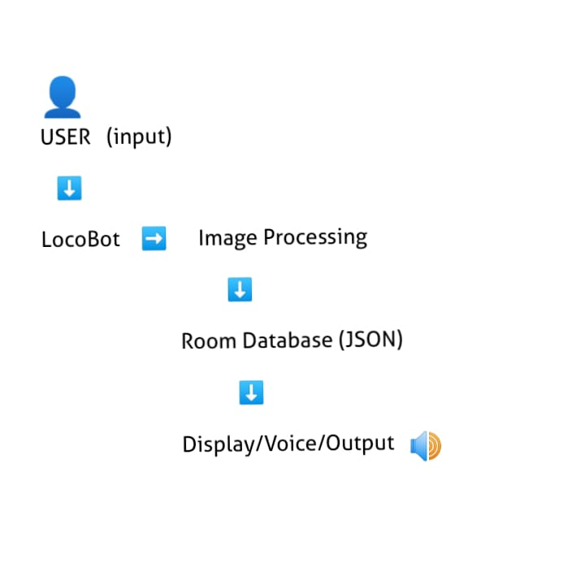

# Functional and Non-Functional Requirements

· **Functional Requirements**:

* Room navigation with image and voice support.
* Dynamic room management (add/delete).
* Voice guidance in Urdu.

· **Non-Functional Requirements**:

* Real-time response and processing.
* Robust error handling in dynamic environments.
* Support for different building layouts.

# References

· D. Khan and Z. Cheng, "Shenzhen Institute of Advanced Technology, Chinese Academy of Sciences, Shenzhen 518055, China," IEEE Transactions on Advanced Computing Systems, 2024.

· S. Ali and M. Asshad, "Department of Information Technology, The University of Haripur, Haripur 22620, Pakistan," IEEE Journal of Information Technology, 2024.

· K. Kiyokawa and H. Uchiyama, "Cybernetics and Reality Engineering Lab, Nara Institute of Science and Technology, Nara 630-0192, Japan," IEEE Transactions on Cybernetics, 2024.

[Recent advances in vision-based indoor navigation: A systematic literature review - ScienceDirect](https://www.sciencedirect.com/science/article/abs/pii/S0097849322000371" \l "preview-section-introduction)

# Project Timeline

Month 1: Requirement Gathering and Initial Design

Month 2: Hardware Setup and Initial Coding

Month 3: Voice Recognition and Image Processing Integration

Month 4: Database and Room Management System Implementation

Month 5: Testing and Debugging

Month 6: Final Deployment and Documentation